* 1. **System Development Life Cycle:**

**Planning:**

1. **Project Overview:** 
   * Project Title: 5odark
   * Objective: Create a mobile application that connect between farmers and sellers or buyers in the agricultural market to improve supply chain efficiency and promote local products.

* Benefits: Increases farmers' market access , lowers costs for buyers, supports local agriculture and Improves pricing transparency.

1. **Partnership:**

* Shipping and delivery companies.
* Agricultural organizations.

1. **Stakeholders:**

* Factories
* Customer
* Restaurants and Cafes
* Farmers’ Owners
* Delivery Companies
* Retailer

1. **Define Research Objectives:**

* Create a mobile application that connects farmers and sellers or buyers in the agricultural market to improve supply chain efficiency and promote local products.
* Increases farmers' market access, lowers costs for buyers, supports local agriculture and Improves pricing transparency.

1. **Information Gathering:**

* We made this survey to gather some information, we found that most people suffering from high prices of vegetables or fruits and price differentials from seller to seller, find it difficult to get vegetables or fruits of high quality or reach some types of vegetables or fruits, difficultly to order vegetables or fruits from home and The lack of different payment methods.

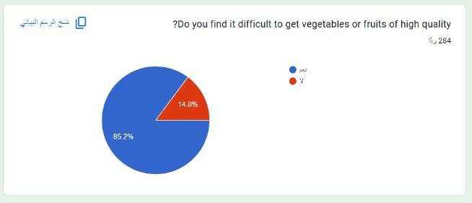

**System design:**  We will design the system through:

We design our software solution to meet the requirements that determined in the requirements analysis stage.

So, the Data Flow diagrams, flow chart, class diagrams, use case diagrams, ERD and other graphs we designed to explain how our application will be run and determine the software, and network infrastructure that will be used by the system.

1. **Implementation phase:**

Technology stack and tools We will use:

* + **Programming Languages and Technologies:** 
    - Flutter: To Develop mobile web and desktop applications.
    - PHP, Python: For server-side development and managing the database.
    - Firebase: To handle database operations and store information about parking spaces.
  + **Data Security:** 
    - SSL/TLS: To secure app communications and protect sensitive data.
    - Implement data security measures such as data encryption and verification procedures to protect user information.
  + **Development Tools:**
    - Integrated Development Environment (IDE) such as Visual Studio
  + **Electronic Payment Technologies:** 
    - Integration of an electronic payment system such as Visa, MasterCard to enable users to pay reservation fees online.

1. **Methodology Used:**

- **Agile Methodology:** Scrum

**Why we want to use agile method?**

* + - because it helps to ensure that development teams complete projects on time and within budget. It also helps to improve communication between the development team and the product owner.
    - Additionally, Agile development methodology can help reduce the risks associated with complex projects. It allows for development teams to make changes quickly and easily without affecting the overall project timeline.
    - **Advantage:** 
      * **Increased flexibility:** Agile development is more flexible than other project management methodologies. Development teams can make changes on the fly more easily.
      * **Improved communication:** Agile development helps to improve communication between the development team and the product owner. Because of this, there is a greater focus on collaboration and feedback.
      * **Reduced risks:** Agile development can help to reduce the risks associated with complex projects. By breaking down complex projects into smaller sprints, project managers can dissect them and achieve shareholder demands.
      * **Increased customer satisfaction:** Agile development environments often lead to increased customer satisfaction. This is because the customer is involved in the development process and provides feedback at each stage of the project.
* **Disadvantage:**
* **Limited control:** Because agile development is more flexible, it can be difficult for a project owner to exert control over the project. This is a problem for projects that need to meet strict deadlines or stay within a certain budget.
* **Lack of documentation:** Agile development often produces less documentation than other project management methodologies. This is an issue for projects that require extensive documentation.
* **High level of collaboration:** The high level of collaboration required by agile development can be a problem for remote teams that are not used to working together. This can lead to conflict and frustration.
* **Complex projects can be lengthy:** Agile development often requires more time than other project management methodologies. This is due to the need for more frequent meetings and the need to create more documentation.

* **Scrum*:*** It makes frequent collaboration among the team members that leads to interpersonal relationships and trust among them.
* **Advantage:** 
  + 1. Help teams complete project deliverables quickly and efficiently.
    2. Ensures effective use of time and money.
    3. Large projects are divided into easily manageable sprints.
    4. Developments are coded and tested during the sprint review.
    5. Works well for fast-moving development projects
    6. The team gets clear visibility through scrum meetings.
    7. Scrum, being agile, adopts feedback from customers and stakeholders.
    8. Short sprints enable changes based on feedback a lot more easily.
    9. The individual effort of each team member is visible during daily scrum meetings.
* **Disadvantage:** 
  + 1. Often leads to scope creep, due to the lack of a definite end-date.
    2. The chances of project failure are high if individuals aren't very committed or cooperative.
    3. Adopting the Scrum framework in large teams is challenging.
    4. The framework can be successful only with experienced team members.
    5. If any team member leaves in the middle of a project, it can have a huge negative impact on the project.
    6. Quality is hard to implement until the team goes through an aggressive testing process.

**System Testing and Evaluation:**

* **Functional Testing:**
  + - Verify that each function of the "5odark" app works as intended.
    - Conduct tests to ensure that users can perform key actions such as browsing products, adding products to the cart, customizing products, and completing orders.
    - Test the interactions between different modules and components of the system.
    - Ensure that data is exchanged correctly and that there are no integration issues.
    - Test transactions with different currencies and amounts to ensure that the app can handle various payment scenarios.
    - Test the refund and cancellation processes. Verify that refunds are processed correctly, and that the user receives proper notifications.
    - Confirm that user authentication and authorization mechanisms are in place to prevent unauthorized access to payment-related features.
    - Identify and address potential security vulnerabilities.
    - Test for issues such as unauthorized access, data breaches, and other security risks.
* **Usability Testing:**
  + - Evaluate the overall user experience and interface design.
    - Ensure that the app is user-friendly and that users can easily navigate and accomplish tasks.